Letters MIS Documentation

***Release 0.0.1***

**AjmalNasiri**

**Document Tracking System**  
The Document Tracking System is a web-based application developed using the Laravel framework and MySQL database. It provides a centralized platform for managing and tracking various types of documents, such as letters, memos, reports, and more.

1. **Important:** User Authentication and Authorization: The system includes user authentication and role-based access control, allowing administrators to manage user accounts and assign appropriate roles and permissions.
2. Document Creation and Management: Users can create new documents, provide necessary details such as title, sender, recipient, description, and upload attachments. The system supports different document types and provides a user-friendly interface for managing and organizing documents.
3. Document Tracking and Status Updates: Each document is assigned a unique tracking number, allowing users to easily track the status and progress of the document throughout its lifecycle. Users can update the status, add comments, and attach relevant files.
4. Search and Filtering: The system provides advanced search and filtering capabilities to help users find specific documents based on various criteria, such as title, sender, recipient, date range, keywords, and document type.
5. Notifications and Reminders: Users receive notifications and reminders for pending tasks, upcoming deadlines, or any updates related to the documents they are involved in. This ensures timely actions and keeps users informed about the progress of their documents.
6. Reporting and Analytics: The system offers built-in reporting features to generate various reports, such as document statistics, tracking history, pending documents, and more. These reports provide valuable insights into the document management process and help in decision-making.
7. Integration with Email and Messaging: The system can be integrated with email services to send notifications, reminders, and document-related updates directly to users' email accounts. Additionally, it may support internal messaging or chat functionality to facilitate communication among users.
8. Audit Trail and Versioning: The system maintains an audit trail, recording all activities and changes made to documents, including user actions, updates, and modifications. It also supports versioning, allowing users to track and manage different versions of a document.
9. Security and Data Privacy: The application implements security measures to protect sensitive data, including user authentication, secure file uploads, and encryption of confidential information. It adheres to data privacy regulations and ensures compliance with relevant standards.

**Installation and configuration**

My repository link is [AjmalNasiri/letters_Management_system (github.com)](https://github.com/AjmalNasiri/letters_Management_system)

Clone it use git clone <https://github.com/AjmalNasiri/letters_Management_system.git>

After cloning use composer install command

After that import the data base or run the migration command php artisan migrate

After migration run the database seeder separatedley for each user one for admin and give the role for id=1

And one for department only give permission for it create_order command php artisan db:seed

After that run the project by command php artisan serve

And go to browser type password and email

When you enter it give you undefined page like [Not Found](http://127.0.0.1:8000/undefined) please erase the undefined and click on <http://127.0.0.1:8000/>

Because I have not time to configure it unfortunately please forgot it

Table in letters mis

Its diagram is

|  |  |  |
| --- | --- | --- |
|  | Table of contents |  |
| 1 archives |  | Page number: 2 |
| 2 comment_histories |  | Page number: 3 |
| 3 departments |  | Page number: 4 |
| 4 docment_assigned_departments |  | Page number: 5 |
| 5 documents |  | Page number: 6 |
| 6 failed_jobs |  | Page number: 7 |
| 7 migrations |  | Page number: 8 |
| 8 model_has_permissions |  | Page number: 9 |
| 9 model_has_roles |  | Page number: 10 |
| 10 password_resets |  | Page number: 11 |
| 11 permissions |  | Page number: 12 |
| 12 personal_access_tokens |  | Page number: 13 |
| 13 requested_from_to_sources |  | Page number: 14 |
| 14 roles |  | Page number: 15 |
| 15 role_has_permissions |  | Page number: 16 |
| 16 users |  | Page number: 17 |
| 17 Relational schema Page number: 18 | | |

# 1 archives

Creation: Oct 04, 2023 at 12:27 AM

|  |  |  |  |  |  |  |  |  |
| --- | --- | --- | --- | --- | --- | --- | --- | --- |
| **Column** | **Type** | **Attributes** | **Null** | **Default** | **Extra** | **Links to** | **Comments** | **MIME** |
| id | bigint(20) | UNSIGNED | No |  | auto_increment |  |  |  |
| document_id | bigint(20) | UNSIGNED | No |  |  | -> documents.id  ON UPDATE RESTRICT  ON DELETE RESTRICT |  |  |
| user_id | bigint(20) | UNSIGNED | No |  |  | -> users.id  ON UPDATE RESTRICT  ON DELETE RESTRICT |  |  |
| location | varchar(255  ) |  | Yes | NULL |  |  |  |  |
| deleted_at | timestamp |  | Yes | NULL |  |  |  |  |
| created_at | varchar(255  ) |  | Yes | NULL |  |  |  |  |
| updated_at | varchar(255  ) |  | Yes | NULL |  |  |  |  |

# 2 comment_histories

Creation: Oct 04, 2023 at 12:27 AM

|  |  |  |  |  |  |  |  |  |
| --- | --- | --- | --- | --- | --- | --- | --- | --- |
| **Column** | **Type** | **Attributes** | **Null** | **Default** | **Extra** | **Links to** | **Comments** | **MIME** |
| id | bigint(20) | UNSIGNED | No |  | auto_increment |  |  |  |
| docment_assign  ed_department  _id | bigint(20) | UNSIGNED | No |  |  | -> docment_assigned_depart ments.id  ON UPDATE RESTRICT  ON DELETE RESTRICT |  |  |
| user_id | bigint(20) | UNSIGNED | No |  |  | -> users.id  ON UPDATE RESTRICT  ON DELETE RESTRICT |  |  |
| department_co mment | varchar(255  ) |  | Yes | NULL |  |  |  |  |
| followup_comm ent | varchar(255  ) |  | Yes | NULL |  |  |  |  |
| date | varchar(255  ) |  | No |  |  |  |  |  |
| created_at | varchar(255  ) |  | Yes | NULL |  |  |  |  |
| updated_at | varchar(255  ) |  | Yes | NULL |  |  |  |  |
| deleted_at | timestamp |  | Yes | NULL |  |  |  |  |

# 3 departments

Creation: Oct 04, 2023 at 12:26 AM

|  |  |  |  |  |  |  |  |  |
| --- | --- | --- | --- | --- | --- | --- | --- | --- |
| **Column** | **Type** | **Attributes** | **Null** | **Default** | **Extra** | **Links to** | **Comments** | **MIME** |
| id | bigint(20) | UNSIGNED | No |  | auto_increment |  |  |  |
| name | varchar(255  ) |  | No |  |  |  |  |  |
| manager_name | varchar(255  ) |  | No |  |  |  |  |  |
| created_at | varchar(255  ) |  | Yes | NULL |  |  |  |  |
| updated_at | varchar(255  ) |  | Yes | NULL |  |  |  |  |
| deleted_at | timestamp |  | Yes | NULL |  |  |  |  |

# 4 docment_assigned_departments

Creation: Oct 04, 2023 at 12:27 AM

|  |  |  |  |  |  |  |  |  |
| --- | --- | --- | --- | --- | --- | --- | --- | --- |
| **Column** | **Type** | **Attributes** | **Null** | **Default** | **Extra** | **Links to** | **Comments** | **MIME** |
| id | bigint(20) | UNSIGNED | No |  | auto_increment |  |  |  |
| department_id | bigint(20) | UNSIGNED | No |  |  | -> departments.id  ON UPDATE RESTRICT  ON DELETE RESTRICT |  |  |
| document_id | bigint(20) | UNSIGNED | No |  |  | -> documents.id  ON UPDATE RESTRICT  ON DELETE RESTRICT |  |  |
| user_id | bigint(20) | UNSIGNED | No |  |  | -> users.id  ON UPDATE RESTRICT  ON DELETE RESTRICT |  |  |
| assign_date | varchar(255  ) |  | No |  |  |  |  |  |
| deadline | varchar(255  ) |  | No |  |  |  |  |  |
| status | tinyint(4) |  | No |  |  |  |  |  |
| complation_dat e | varchar(255  ) |  | Yes | NULL |  |  |  |  |
| outcome | varchar(255  ) |  | Yes | NULL |  |  |  |  |
| attachments | varchar(255  ) |  | Yes | NULL |  |  |  |  |
| supervisor_deci sion | text |  | Yes | NULL |  |  |  |  |
| created_at | varchar(255  ) |  | Yes | NULL |  |  |  |  |
| updated_at | varchar(255  ) |  | Yes | NULL |  |  |  |  |
| deleted_at | timestamp |  | Yes | NULL |  |  |  |  |

# 5 documents

Creation: Oct 04, 2023 at 12:27 AM

|  |  |  |  |  |  |  |  |  |
| --- | --- | --- | --- | --- | --- | --- | --- | --- |
| **Column** | **Type** | **Attributes** | **Null** | **Default** | **Extra** | **Links to** | **Comments** | **MIME** |
| id | bigint(20) | UNSIGNED | No |  | auto_increment |  |  |  |
| document_no | int(11) |  | No |  |  |  |  |  |
| title | varchar(255  ) |  | No |  |  |  |  |  |
| requested_from _to_source_id | bigint(20) | UNSIGNED | No |  |  | ->  requested_from_to_sources.id  ON UPDATE RESTRICT  ON DELETE RESTRICT |  |  |
| recieved_date | varchar(255  ) |  | No |  |  |  |  |  |
| startup_depart ment | varchar(255  ) |  | Yes | NULL |  |  |  |  |
| details | text |  | No |  |  |  |  |  |
| document_uniq ue_id | char(36) |  | No |  |  |  |  |  |
| status | int(11) |  | No |  |  |  |  |  |
| attachments | varchar(255  ) |  | Yes | NULL |  |  |  |  |
| user_id | bigint(20) | UNSIGNED | No |  |  | -> users.id  ON UPDATE RESTRICT  ON DELETE RESTRICT |  |  |
| deleted_at | timestamp |  | Yes | NULL |  |  |  |  |
| created_at | varchar(255  ) |  | Yes | NULL |  |  |  |  |
| updated_at | varchar(255  ) |  | Yes | NULL |  |  |  |  |

1. **failed_jobs**

|  |  |  |  |  |  |  |  |  |
| --- | --- | --- | --- | --- | --- | --- | --- | --- |
| **Column** | **Type** | **Attributes** | **Null** | **Default** | **Extra** | **Links to** | **Comments** | **MIME** |
| id | bigint(20) | UNSIGNED | No |  | auto_increment |  |  |  |
| uuid | varchar(255  ) |  | No |  |  |  |  |  |
| connection | text |  | No |  |  |  |  |  |
| queue | text |  | No |  |  |  |  |  |
| payload | longtext |  | No |  |  |  |  |  |
| exception | longtext |  | No |  |  |  |  |  |
| failed_at | timestamp |  | No | current_tim estamp() |  |  |  |  |

1. **migrations**

|  |  |  |  |  |  |  |  |  |
| --- | --- | --- | --- | --- | --- | --- | --- | --- |
| **Column** | **Type** | **Attributes** | **Null** | **Default** | **Extra** | **Links to** | **Comments** | **MIME** |
| id | int(10) | UNSIGNED | No |  | auto_increment |  |  |  |
| migration | varchar(255  ) |  | No |  |  |  |  |  |
| batch | int(11) |  | No |  |  |  |  |  |

1. **model_has_permissions**

|  |  |  |  |  |  |  |  |  |
| --- | --- | --- | --- | --- | --- | --- | --- | --- |
| **Column** | **Type** | **Attributes** | **Null** | **Default** | **Extra** | **Links to** | **Comments** | **MIME** |
| permission_id | bigint(20) | UNSIGNED | No |  |  | -> permissions.id  ON UPDATE RESTRICT  ON DELETE CASCADE |  |  |
| model_type | varchar(255  ) |  | No |  |  |  |  |  |
| model_id | bigint(20) | UNSIGNED | No |  |  |  |  |  |

1. **model_has_roles**

|  |  |  |  |  |  |  |  |  |
| --- | --- | --- | --- | --- | --- | --- | --- | --- |
| **Column** | **Type** | **Attributes** | **Null** | **Default** | **Extra** | **Links to** | **Comments** | **MIME** |
| role_id | bigint(20) | UNSIGNED | No |  |  | -> roles.id  ON UPDATE RESTRICT  ON DELETE CASCADE |  |  |
| model_type | varchar(255  ) |  | No |  |  |  |  |  |
| model_id | bigint(20) | UNSIGNED | No |  |  |  |  |  |

1. **password_resets**

|  |  |  |  |  |  |  |  |  |
| --- | --- | --- | --- | --- | --- | --- | --- | --- |
| **Column** | **Type** | **Attributes** | **Null** | **Default** | **Extra** | **Links to** | **Comments** | **MIME** |
| email | varchar(255  ) |  | No |  |  |  |  |  |
| token | varchar(255  ) |  | No |  |  |  |  |  |
| created_at | timestamp |  | Yes | NULL |  |  |  |  |

1. **permissions**

|  |  |  |  |  |  |  |  |  |
| --- | --- | --- | --- | --- | --- | --- | --- | --- |
| **Column** | **Type** | **Attributes** | **Null** | **Default** | **Extra** | **Links to** | **Comments** | **MIME** |
| id | bigint(20) | UNSIGNED | No |  | auto_increment |  |  |  |
| name | varchar(255  ) |  | No |  |  |  |  |  |
| guard_name | varchar(255  ) |  | No |  |  |  |  |  |
| created_at | timestamp |  | Yes | NULL |  |  |  |  |
| updated_at | timestamp |  | Yes | NULL |  |  |  |  |

1. **personal_access_tokens**

|  |  |  |  |  |  |  |  |  |
| --- | --- | --- | --- | --- | --- | --- | --- | --- |
| **Column** | **Type** | **Attributes** | **Null** | **Default** | **Extra** | **Links to** | **Comments** | **MIME** |
| id | bigint(20) | UNSIGNED | No |  | auto_increment |  |  |  |
| tokenable_type | varchar(255  ) |  | No |  |  |  |  |  |
| tokenable_id | bigint(20) | UNSIGNED | No |  |  |  |  |  |
| name | varchar(255  ) |  | No |  |  |  |  |  |
| token | varchar(64) |  | No |  |  |  |  |  |
| abilities | text |  | Yes | NULL |  |  |  |  |
| last_used_at | timestamp |  | Yes | NULL |  |  |  |  |
| created_at | timestamp |  | Yes | NULL |  |  |  |  |
| updated_at | timestamp |  | Yes | NULL |  |  |  |  |

# 13 requested_from_to_sources

Creation: Oct 04, 2023 at 12:27 AM

|  |  |  |  |  |  |  |  |  |
| --- | --- | --- | --- | --- | --- | --- | --- | --- |
| **Column** | **Type** | **Attributes** | **Null** | **Default** | **Extra** | **Links to** | **Comments** | **MIME** |
| id | bigint(20) | UNSIGNED | No |  | auto_increment |  |  |  |
| source_name | varchar(255  ) |  | No |  |  |  |  |  |
| deleted_at | timestamp |  | Yes | NULL |  |  |  |  |
| created_at | varchar(255  ) |  | Yes | NULL |  |  |  |  |
| updated_at | varchar(255  ) |  | Yes | NULL |  |  |  |  |

1. **roles**

|  |  |  |  |  |  |  |  |  |
| --- | --- | --- | --- | --- | --- | --- | --- | --- |
| **Column** | **Type** | **Attributes** | **Null** | **Default** | **Extra** | **Links to** | **Comments** | **MIME** |
| id | bigint(20) | UNSIGNED | No |  | auto_increment |  |  |  |
| name | varchar(255  ) |  | No |  |  |  |  |  |
| guard_name | varchar(255  ) |  | No |  |  |  |  |  |
| created_at | timestamp |  | Yes | NULL |  |  |  |  |
| updated_at | timestamp |  | Yes | NULL |  |  |  |  |

1. **role_has_permissions**

|  |  |  |  |  |  |  |  |  |
| --- | --- | --- | --- | --- | --- | --- | --- | --- |
| **Column** | **Type** | **Attributes** | **Null** | **Default** | **Extra** | **Links to** | **Comments** | **MIME** |
| permission_id | bigint(20) | UNSIGNED | No |  |  | -> permissions.id  ON UPDATE RESTRICT  ON DELETE CASCADE |  |  |
| role_id | bigint(20) | UNSIGNED | No |  |  | -> roles.id  ON UPDATE RESTRICT  ON DELETE CASCADE |  |  |

1. **users**

|  |  |  |  |  |  |  |  |  |
| --- | --- | --- | --- | --- | --- | --- | --- | --- |
| **Column** | **Type** | **Attributes** | **Null** | **Default** | **Extra** | **Links to** | **Comments** | **MIME** |
| id | bigint(20) | UNSIGNED | No |  | auto_increment |  |  |  |
| name | varchar(255  ) |  | No |  |  |  |  |  |
| email | varchar(255  ) |  | No |  |  |  |  |  |
| department_id | bigint(20) | UNSIGNED | No |  |  | -> departments.id  ON UPDATE RESTRICT  ON DELETE RESTRICT |  |  |
| email_verified_a  t | timestamp |  | Yes | NULL |  |  |  |  |
| password | varchar(255  ) |  | No |  |  |  |  |  |
| status | tinyint(1) |  | No | 1 |  |  |  |  |
| created_at | varchar(255  ) |  | Yes | NULL |  |  |  |  |
| updated_at | varchar(255  ) |  | Yes | NULL |  |  |  |  |
| deleted_at | timestamp |  | Yes | NULL |  |  |  |  |

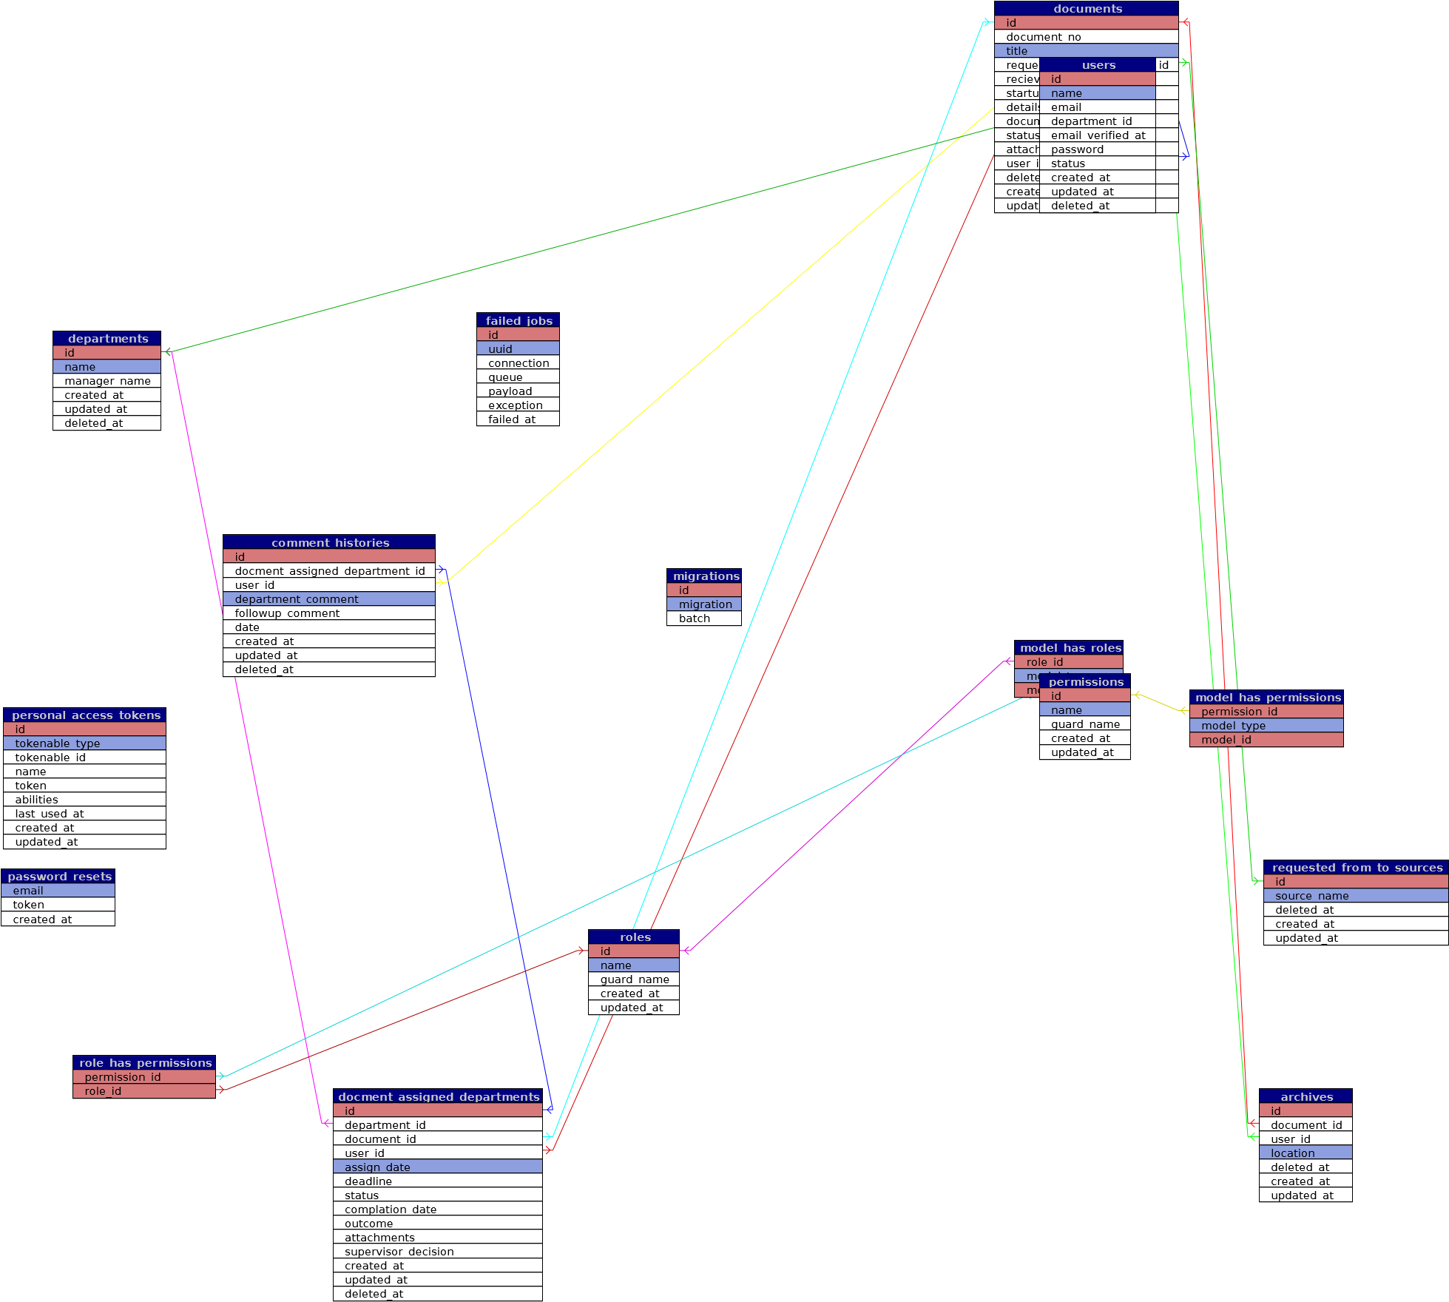[Powered by TCPDF (www.tcpdf.org)](http://www.tcpdf.org)